

Faculty of Medicine

School of Kinesiology and Physical Education

* Dr. Philippe Dixon

Guide to the Data extraction Code

## How the Footsteps were Annotated.

Each video is of 2 minutes. There are 176 participants in total

The sensors were put on the Right foot so we are only considering right foot heelstrike. Whenever “heelstrike” is referred, it’s for right foot only.

All timestamps should be reported upto milliseconds.

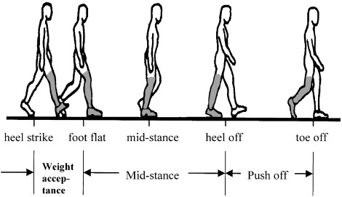We want the timestamp of heel-strike as shown in the figure below(leftmost->heelstrike).

There are a total of 5 surfaces on which the participants were asked to tread. They are numbered as shown in the figure below:

The general order of the tread was:

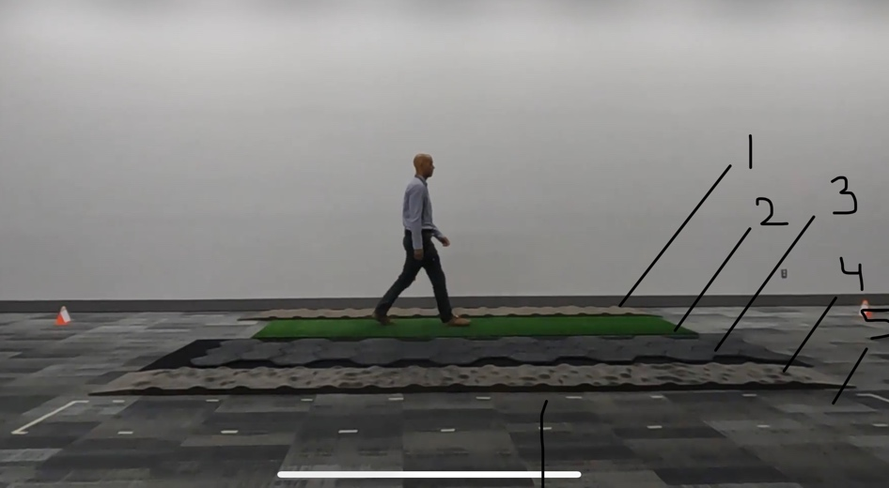surface 1->2->3->4->5->5->4->3->2->1->1->2->3->4->5

However due to the video time limit of 2 minutes some participant did more or less than that which is also fine.

In some cases, participants were confused with the order, if they didn’t complete the whole stretch of a surface, neglect that part.

In exceptional case, the video might be corrupted, in that case enter NULL in the excel sheet.

We only want the timestamp of:

The first and last heelstrike of each surface.

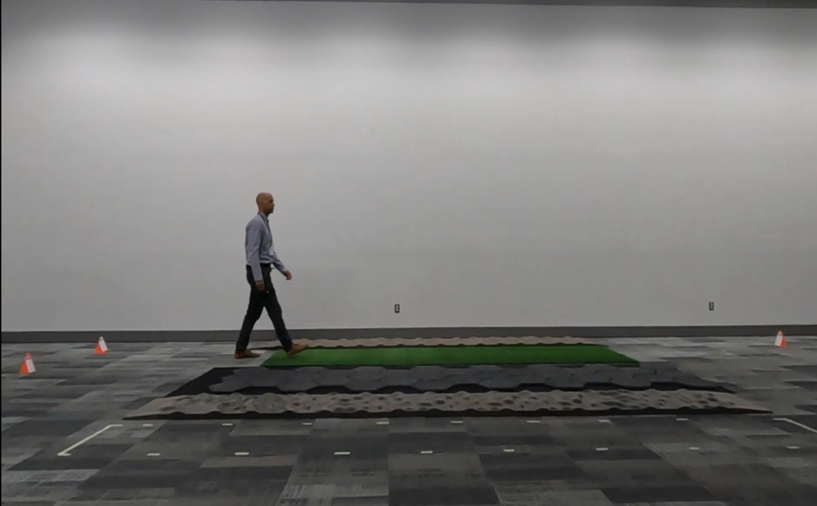For example this snapshot is of first heelstrike of surface 2 of participant 1.

# Method

* From the participant video, timestamps were noted down manually, and compiled into and excel sheet.
* After that, Sync was performed. For that we calculated the time difference between the Xdot and GoPro. A more detailed explanation is given in the “guide to sync code” document.
* With the help of sync code, created tensors in python environments.
* During pre-processing the data, found out that many participants had their sensor excel file missing/corrupted. Out of 155 participants that were synced, now only 118 have proper files.
* Out of these 118 participants, only 99 had proper number of rows. These had to be discarded to maintain data consistency.
* The code takes the magnitude of Gyro_x, Gyro_y, Gyro_z of all the channels(shank,trunk, foot and thigh) of all the participants and creates tensor out of it.  
  The tensor contains the sensor data corresponding to each participant. [ Person x Channels x Samples x Signal ]

# Useful Links:

NACOB data : [Data](https://drive.google.com/drive/folders/1vctRYSgTTUDm_7WZ9VlGoCnWw-dCC8to)

Timestamp excel sheet: [Video Timestamp.xlsx](https://udemontreal-my.sharepoint.com/:x:/r/personal/abhishek_singh_umontreal_ca/Documents/Video%20Timestamp.xlsx?d=w32d814531d2b477d8dd28cf40663ef24&csf=1&web=1&e=3hy6kD)

Thank you

If you have any queries, feel free to reach out to me on:

Email: [abhishek.singh@umontreal.ca](mailto:abhishek.singh@umontreal.ca)

Phone: +15144495467